WEEK 4 ADA LAB

1BM21CS247

Q) BFS TRAVERSAL

SOURCE CODE:

#include<stdio.h>

#include<conio.h>

void bfs(int);

int a[10][10],vis[10],n;

void main()

{

int i,j,src;

printf("enter the number of vertices\n");

scanf("%d",&n);

printf("enter the adjacency matrix\n");

for(i=1;i<=n;i++)

{

for(j=1;j<=n;j++)

{

scanf("%d",&a[i][j]);

}

}

/\*for(i=1;i<=n;i++)

{ if (vis[i]==0)

bfs(i);

}\*/

printf("enter the src vertex\n");

scanf("%d",&src);

printf("nodes reachable from src vertex\n");

bfs(src);

}

void bfs(int v)

{

int q[10],f=1,r=1,u,i;

q[r]=v;

vis[v]=1;

while(f<=r)

{

u=q[f];

printf("%d",u);

for(i=1;i<=n;i++)

{

if(a[u][i]==1 && vis[i]==0)

{

vis[i]=1;

r=r+1;

q[r]=i;

}

}

f=f+1;

}

}

OUTPUT:

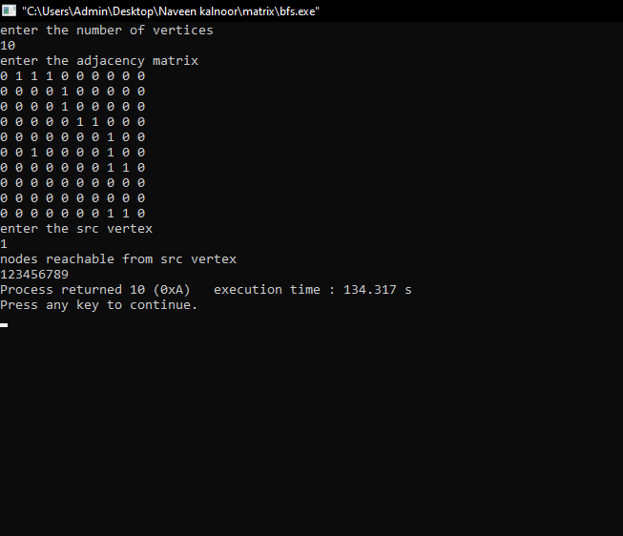

Q) TOPOLOGICAL SORTING

SOURCE CODE:

#include<stdio.h>

#include<conio.h>

void dfs(int);

int a[10][10],vis[10],exp[10],n,j,m;

void main()

{

int i,x,y;

printf("enter the number of vertices\n");

scanf("%d",&n);

for(i=1;i<=n;i++)

{

for(j=1;j<=n;j++)

{

a[i][j]=0;

}

vis[i]=0;

}

printf("enter the number of edges\n");

scanf("%d",&m);

for(i=1;i<=m;i++)

{

printf("enter an edge\n");

scanf("%d %d",&x,&y);

a[x][y]=1;

}

j=0;

for(i=1;i<=n;i++)

{

if(vis[i]==0)

dfs(i);

}

printf("topological sort\n");

for(i=n-1;i>=0;i--)

{

printf("%d\t",exp[i]);

}

getch();

}

void dfs(int v)

{

int i;

vis[v]=1;

for(i=1;i<=n;i++)

{

if(a[v][i]==1 && vis[i]==0)

dfs(i);

}

exp[j++]=v;

}

OUTPUT:

